Tools in LangGraph
We are going to add 3 tools to our chatbot:
- Algorithmic Tool → Performs calculations or algorithm-based tasks.
- Search Tool → Searches the web for relevant information.
- Stock Tool → Fetches the current stock price of a given company.
In LangGraph, we create a ToolNode containing all our tools. The chat_node evaluates whether the user's query requires a tool; if yes, it routes the query to the ToolNode for execution.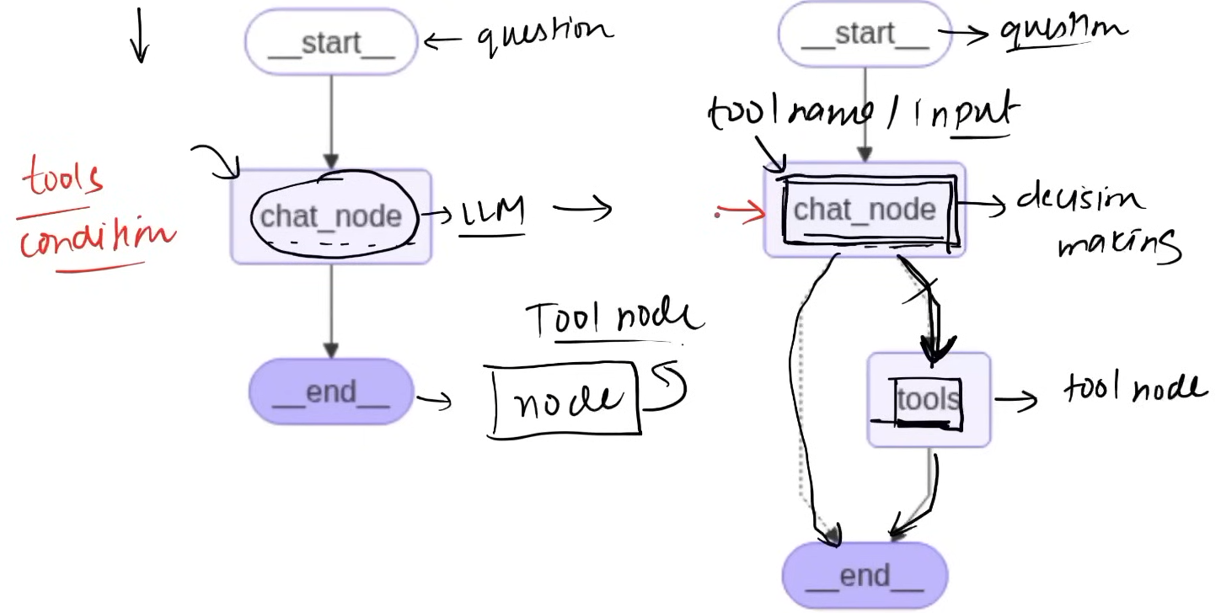
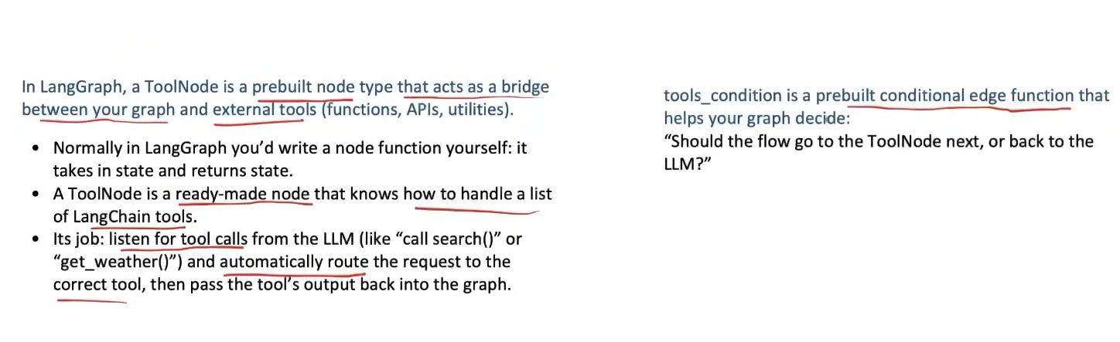

Code:-
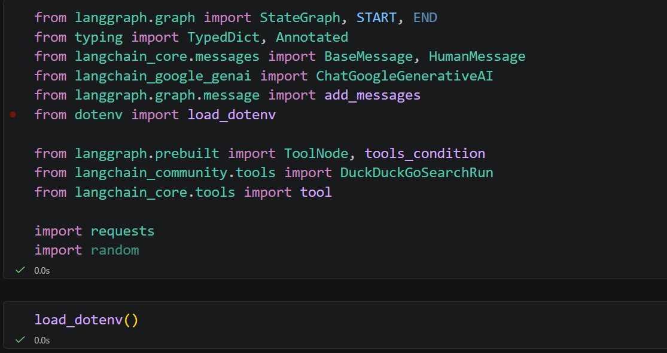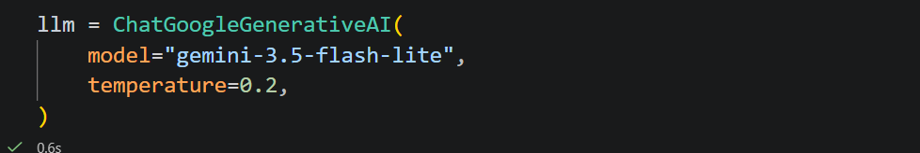
Here, we have two types of tools:
- Pre-built Tool — DuckDuckGo: Since web search is commonly used, LangChain already provides a ready-made DuckDuckGo tool that we can directly use.
- Custom Tool — Calculator: We create our own Python function and use the @tool decorator to convert that function into a LangChain tool.
Any tool at the end of day is just a function after all.
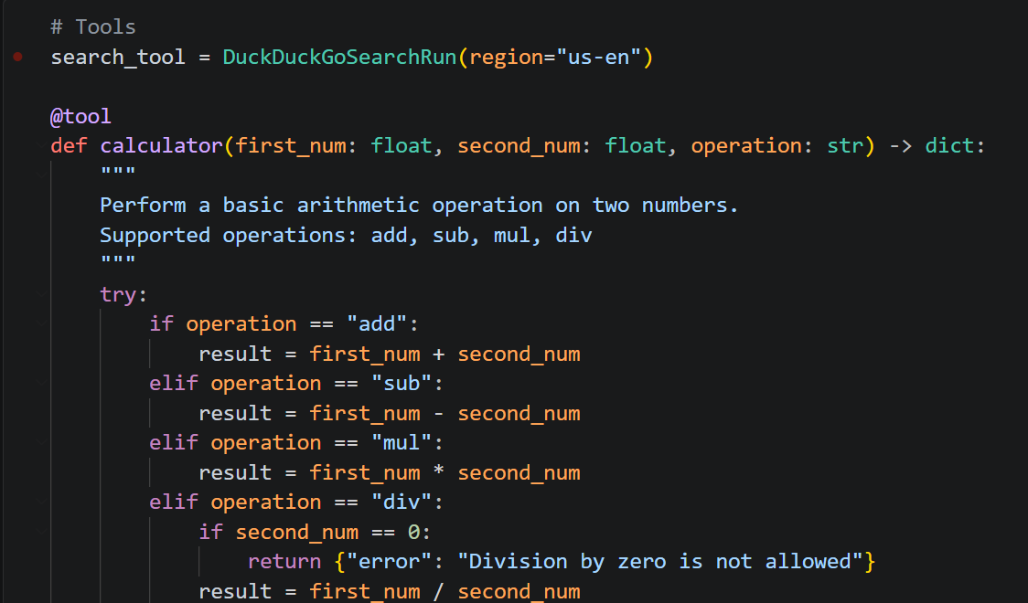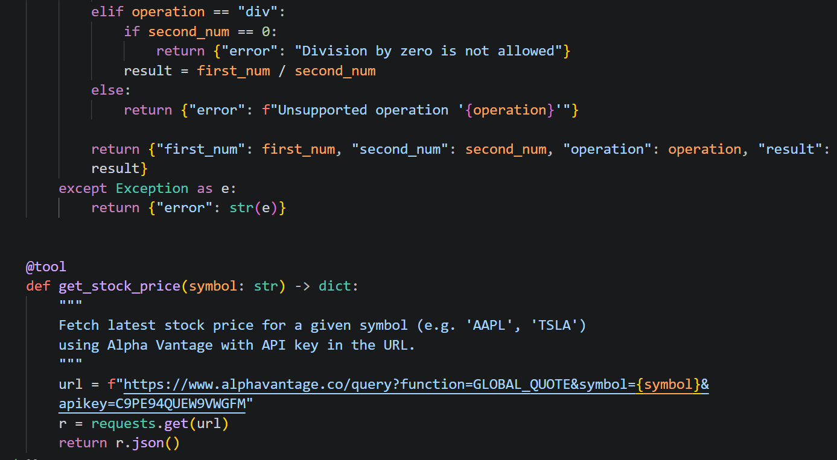
We first create a list of tools that our chatbot will use. Then, we use the built-in bind_tools() method to provide this list to the LLM, making the LLM aware of which tools are available.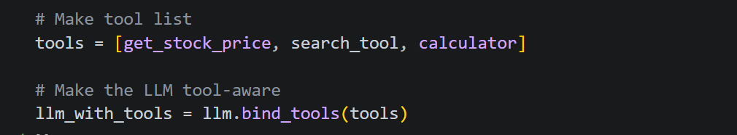
We create a state that stores the messages and appends new messages to the previous ones instead of replacing them.
We create a graph node that takes the messages from the state, passes them to llm_with_tools, and gets the LLM's response back.
We also create tool_node here.
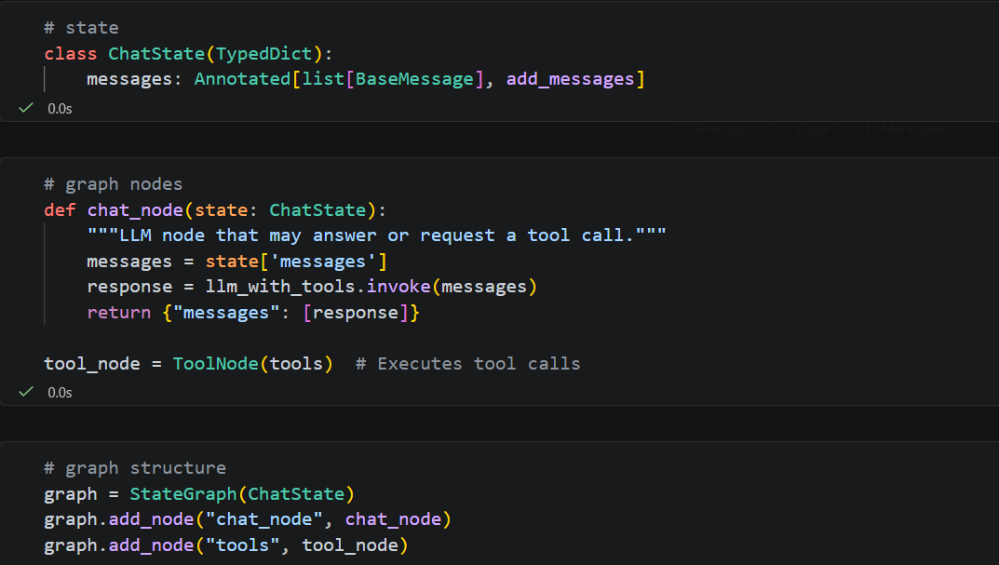
tools_condition
It is a built-in routing function that checks the latest LLM message:
- If the LLM requested a tool → routes to "tools"
- If the LLM didn't request a tool → routes to END
Intuition: You didn't write the decision-maker; LangGraph provides it for you so you don't have to manually check whether the LLM requested a tool.
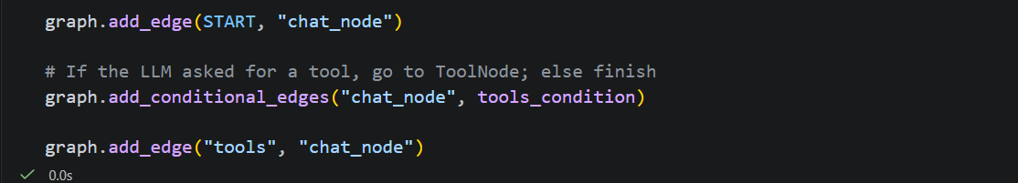
Basically, we take the output returned by the tool, which may be difficult to read, and send it back to the LLM. This time, the LLM does not need to call any tool; it simply formats the tool result into a clear, readable response.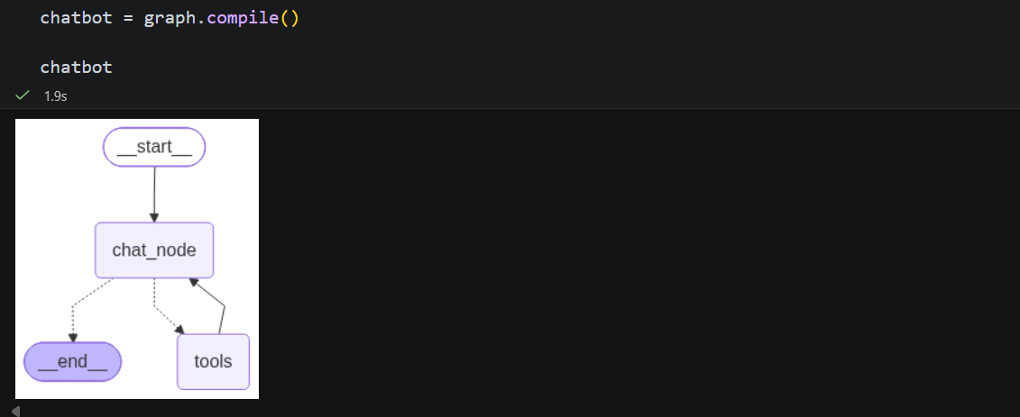
messages → list of messages
[-1] → last message (AIMessage)
.content → content of AI message
[0] → first item in content list
["text"] → actual text
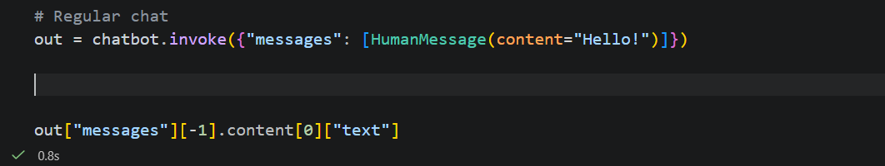
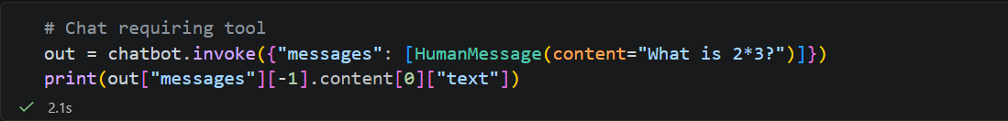
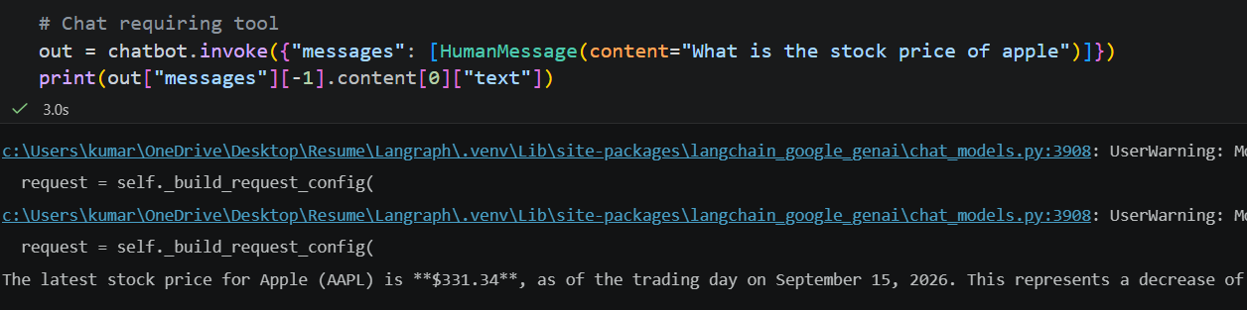
Here we are using both of the tools.
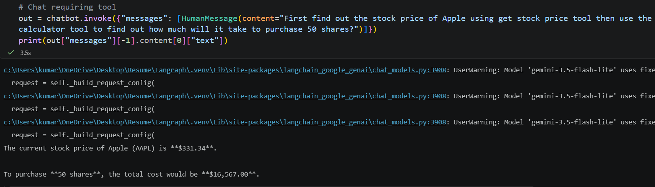
Here, out contains the state with the list of messages. We access the messages list, take the last message, which is the AIMessage, then access its content and extract the first object’s text key.
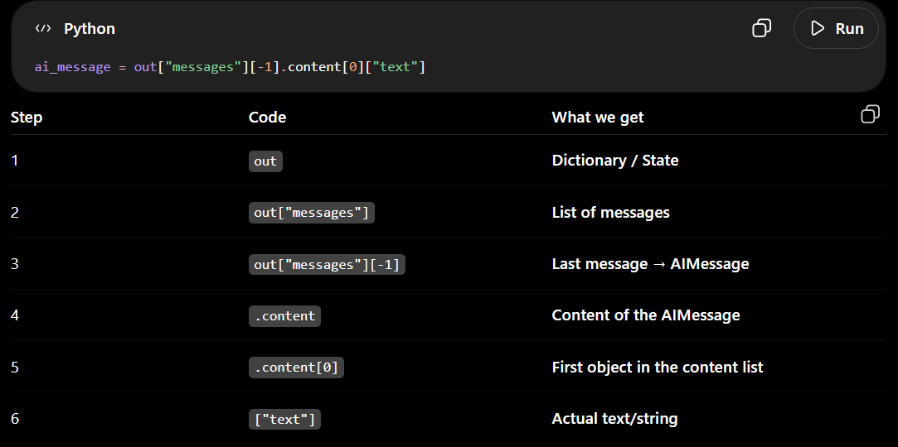
Langsmith tracing it :- Here, we can see multiple nodes because we asked several questions at once. We can also see which node called which tool and the number of tools available for each node.
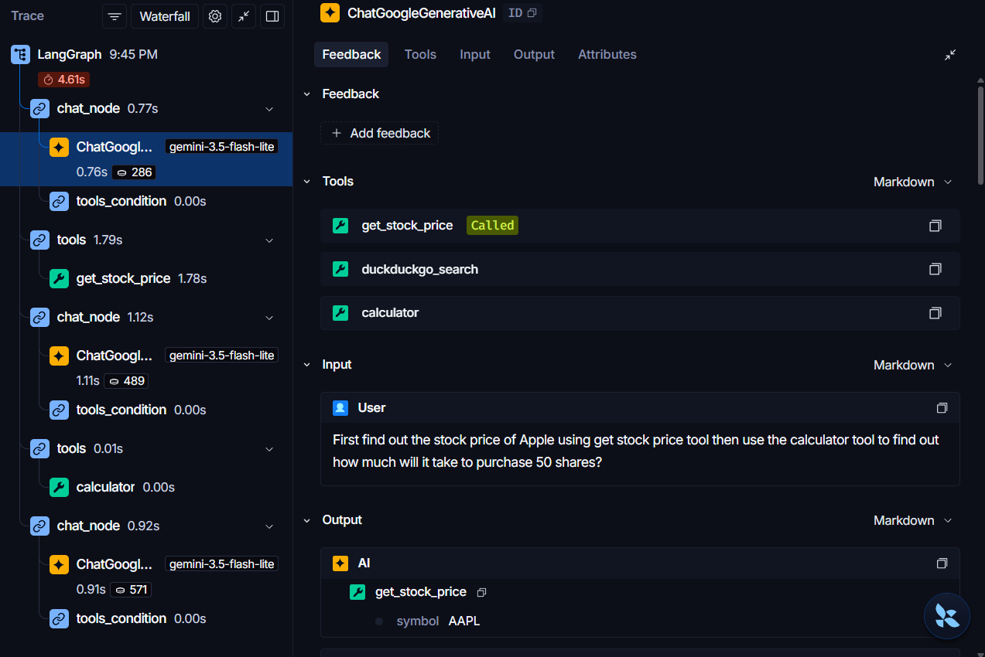
Code:- langgraph_tool_backend.pym, integrating this in our streamlit. There is not much change in backend.
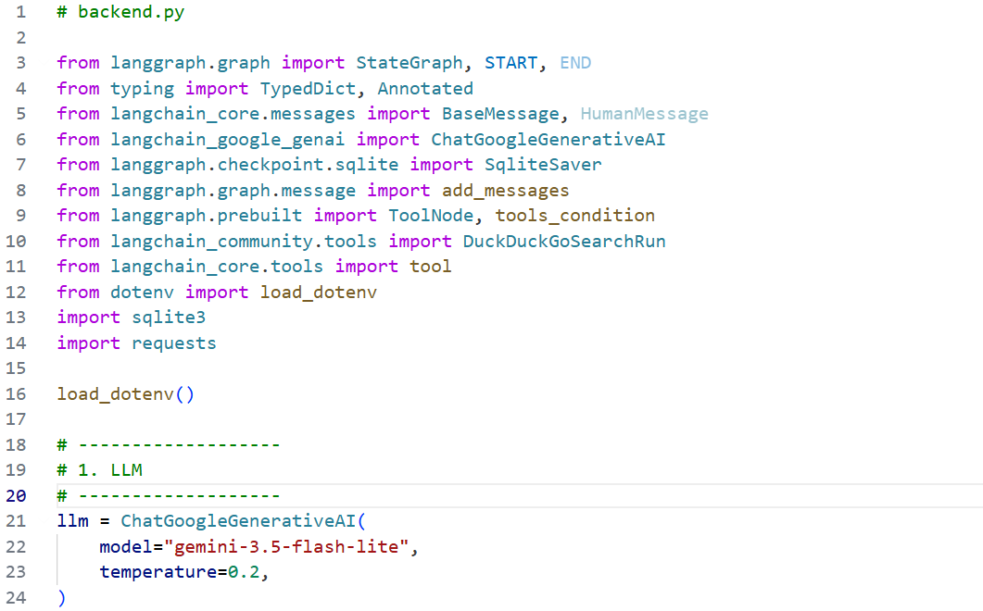
Well we just copied that same code of creating tool. No difference.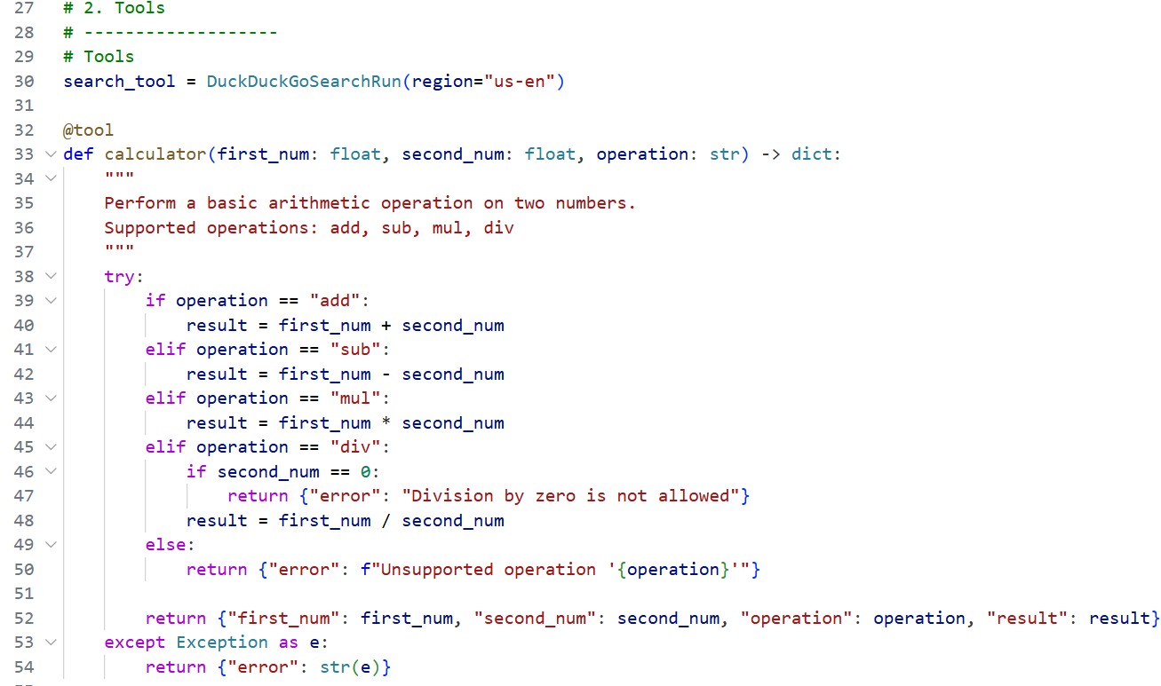
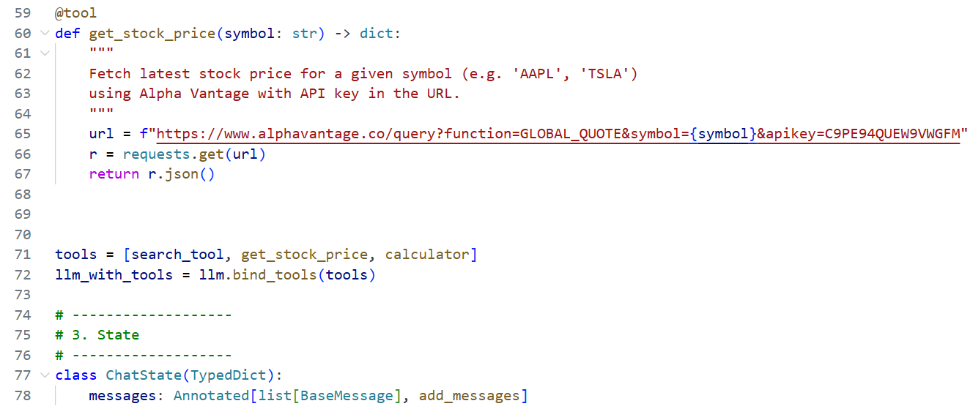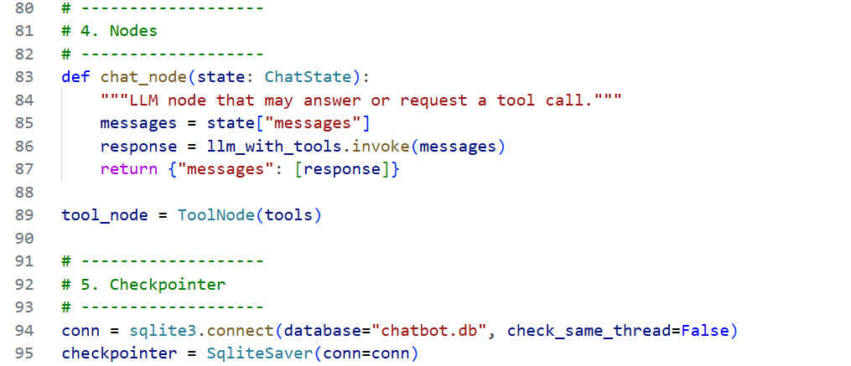
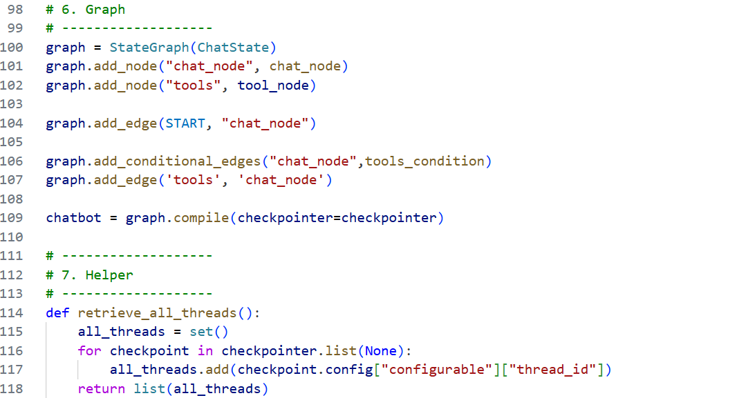

Code :- streamlit_frontend_threading.py, this is front end. There is no major change in this code from previous codes we have written for the streamlit apart from one thing later mentioned.
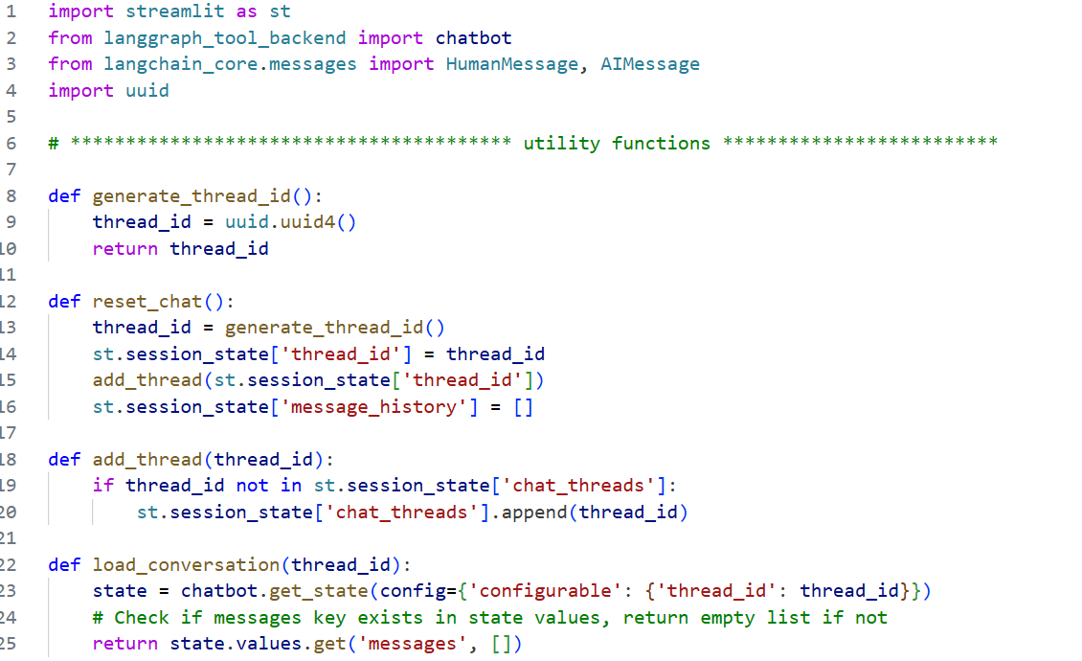

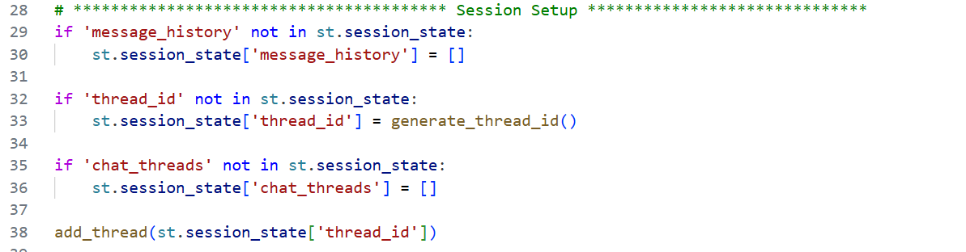
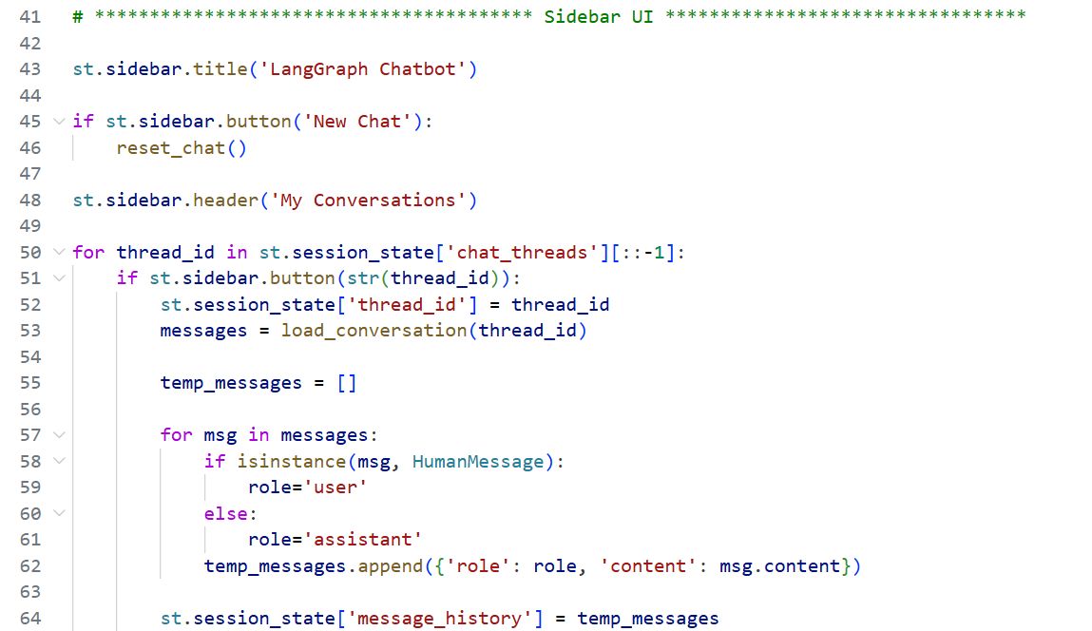
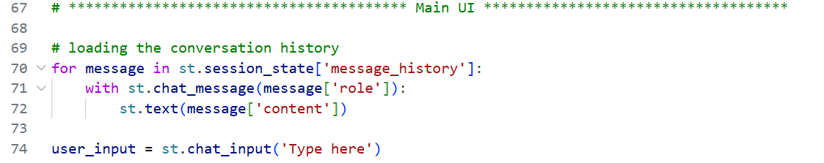

Here, the message response function is slightly changed so that it extracts and returns only the AIMessage, instead of showing all the other messages and information.